Hach WIMS Remote
Overview

1.0 WIMS Remote - Introduction
WIMS Remote allows remote disconnected data entry for WIMS. Data can be collected on any PC or Tablet PC running windows (Windows XP, Windows XP Tablet PC Edition…) and synced to the WIMS database. The WIMS data entry forms (Monthly and Custom) and Lab Cal Samples are sent to the remote and work just like they do in WIMS. After data is entered into WIMS Remote it is then synced with the WIMS database.

1.1 Hardware/Software Requirements
- Access to WIMS version 6.7.4 or newer
Operating system:
- Microsoft Windows 98 with the Y2K Update 2 and IE 4.01 SP2 or later
- Microsoft Windows 98 Second Edition
- Microsoft Windows Millennium
- Microsoft Windows NT Service Pack 5 or later and IE 4.01 SP2 or later
- Microsoft Windows 2000
- Microsoft Windows XP
- Microsoft Windows XP Tablet PC Edition 2002
- Microsoft Windows XP Tablet PC Edition 2005 or later
Data access:
- Microsoft SQL Desktop Edition (MSDE) – included on the WIMS Remote CD.

1.2 WIMS Remote
The WIMS Remote program has the same look and feel of the WIMS client. Basically it supports the Data Manager portion of WIMS and the sync functionality. The data entry forms are designed in the WIMS client and Synced to WIMS Remote.

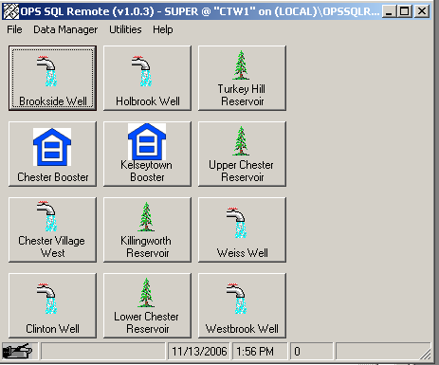

1.3 Initial Upload
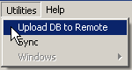
The Initial Upload sends all data (after date specified), variable info, base tables, and data entry forms to the remote. After the Initial Upload you are ready to enter data. From this point forward, only Syncs of changes need to be performed.

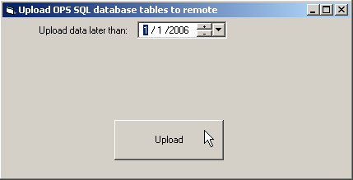

1.4 Entering Data
Entering data is exactly the same as using WIMS. All forms are available to the user and security is applied just as if the user was in WIMS. The only difference is that the user is not connected to the database and data is stored locally until it is synced.
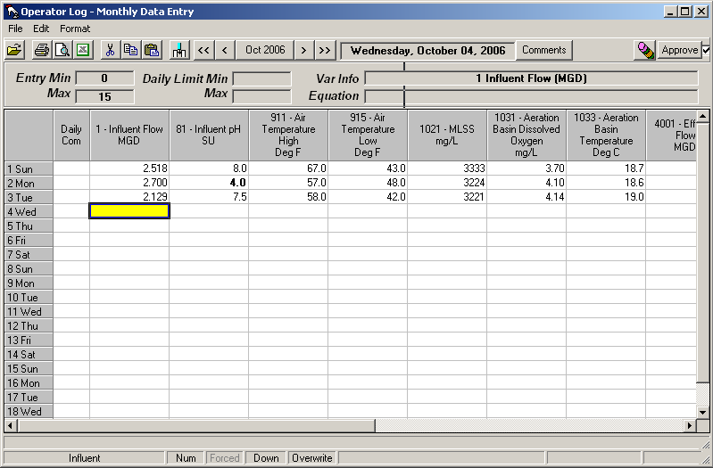
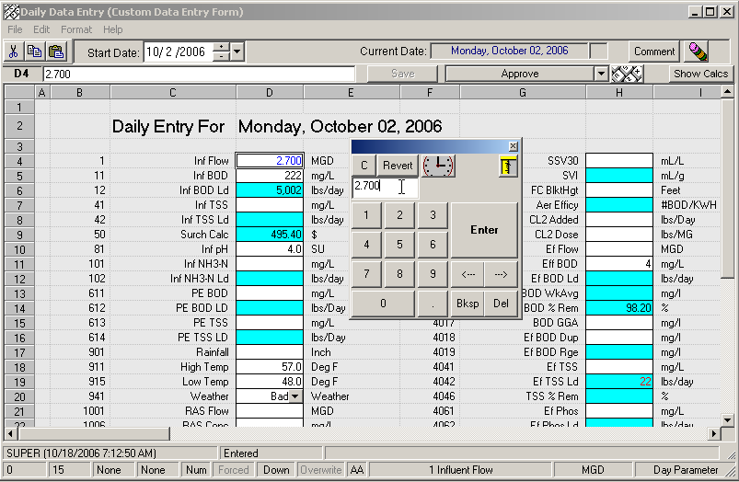

The entry toolbox is available to assist with entry on a tablet PC.

1.5 Syncing Data
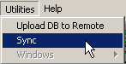
After data entry on the remote has been completed, the user must connect to the WIMS database on the server and Sync the data:

Sync connects to the WIMS database and:
  - Sends data changes from the Remote to the WIMS database since last sync
  - Sends all data changes from WIMS to the Remote since last sync
  - Sends all changes to the base tables (i.e. changes to limits…) to the Remote
  - Sends all forms from WIMS to the Remote that have changed since last sync

1.6 Example Use - Connecticut Water
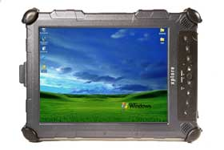
Connecticut Water Company is a publicly traded entity that provides water service to clients across the state of Connecticut. WIMS Remote application is used to collect field data from 615 sampling sites by as many as 30 different data collectors. Connecticut Water chose the ruggedized iX104C2 series tablet pc as the data collection device.

iX104C2 Specs :
http://www.xploretech.com/index.pl?id=2273&isa=Category&op=show
Intel Pentium M 733 - ULV @ 1.1 GHz
256 MB DDR RAM
40GB HDD
10.4" XGA Transmissive LCD
Windows XP Tablet PC edition
IP67 compliant (up to 30cm water)
Integrated 802.11 wireless networking
WiFI and CCX (Cisco Compatible Extensions) certified

At any point in time, WIMS Remote provides remote users with at least 1 year of historical data. Devices are synced with the central WIMS database server that resides in company headquarters in Clinton, CT. The central server runs Microsoft SQL 2000 DBMS on IBM e-Series hardware. The WIMS (full client) application is accessible via Terminal Services for reporting and charting by remote offices.

